M2-3MP
Introduction

2K Indoor Wi-Fi PT Camera
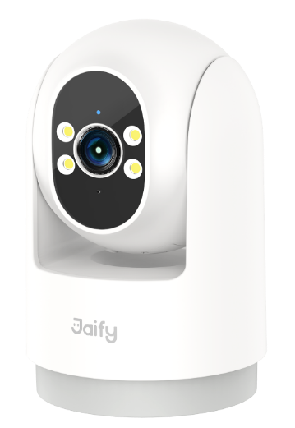
M2-3MP is an indoor Wi-Fi Pan&Tilt camera developed by Jaify, with 2K(3MP) resolution, supporting BT 5.0, Wi-Fi network connection, 360° panoramic monitoring, supporting human detection, human tracking, area vigilance, dual-light vigilance, and full-color night vision. It can be applied to indoor monitoring places such as homes, living rooms, shops,

Main Features





Human Tracking
Wi-Fi Connection
Two-Way
Talk
Human Detection





Area Alert
Full Color
Night Vision
Voice Alarm
Bells
Dual Light
Alert



360° Panorama
Cloud Storage
TF Card
Storage
Dimension

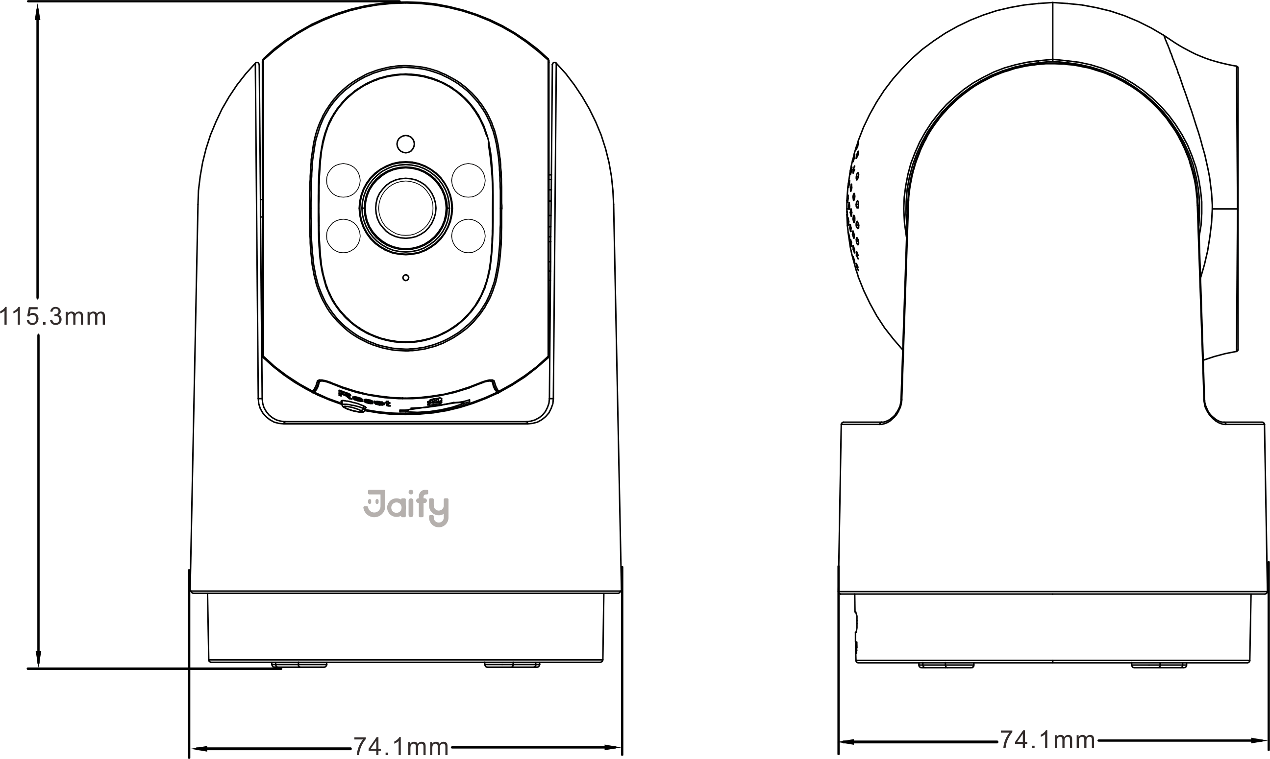

Product Parameters

Camera
Model | M2-3MP
Resolution | 2K(3MP)
Image Sensor | 1/2.8" High-performance Sensor
Min. Illumination | Color: 0.1Lux @ (F2.0, AGC ON); 0 Lux with light  B/W: 0.05 Lux @ (F2.0, AGC ON); 0 Lux with IR
Lens | 4mm@F2.0
Field Of View | Diagonal: 101°, Horizontal: 84°, Vertical: 45°
Shutter Speed | Self-adaptive shutter
Fill Light | 6*850nm IR fill lights&4*white led fill lights
Night Vision | Full-color night vision/Infrared night vision/Dual-light alert
DNR | 3D DNR
Audio Input | Built-in microphone
Audio Output | Built-in speaker
PT Angle | Horizontal 350°, vertical 90°
Video Storage | TF card storage/Cloud storage
Image
Max. Resolution | 2304*1296
Frame Rate | 20FPS
Buttons & Interfaces
Storage Interface | 1*TF card storage interface (max. 256G)
Power Interface | 1*Type-C power interface
Button | 1*Reset button
Compression
Video Compression | H.265/H.264
Audio Compression | G.711A
Network
One-touch Provisioning | Wi-Fi network provisioning
Protocol | JFTECH cloud proprietary protocol
Interface Protocol | JFTECH cloud proprietary protocol
General Function | Anti-Flicker, Dual-Stream, Mirroring, Password Protection, Watermark
Wireless Parameters
Wi-Fi Standard | IEEE 802.11b/g/n
Frequency Range | 2.412 GHz ~ 2.484 GHz
General
Operating Conditions | -10℃ ~ 50℃, Humidity 95% or less (non-condensing)
Power Supply | DC 5V/1A
Night Vision Distance | 10m
Pickup Distance | 5m
Housing Material | ABS, PC
Net Weight | About 206g
Dimensions | About 115mm*74mm*74mm
IP Grade | IP5X

